TRC-LU OPERATIONS REVIEW FORM
(Date)

Department/Division
Head/Deputy
Documenter

STRATEGIC CONTRIBUTIONS
Deliverable/s | Deadline | Status

OPERATIONS REVIEW
Meeting Venue & Schedule
Scoreboard Location & OIC

ACTION POINTS
Action Point | Responsible Person | Target Date | Status

RECOGNITION
How Wins Are Celebrated
How Best Performers Are Recognized
Frequency

Prepared by:

Approved by: (Unit Head)


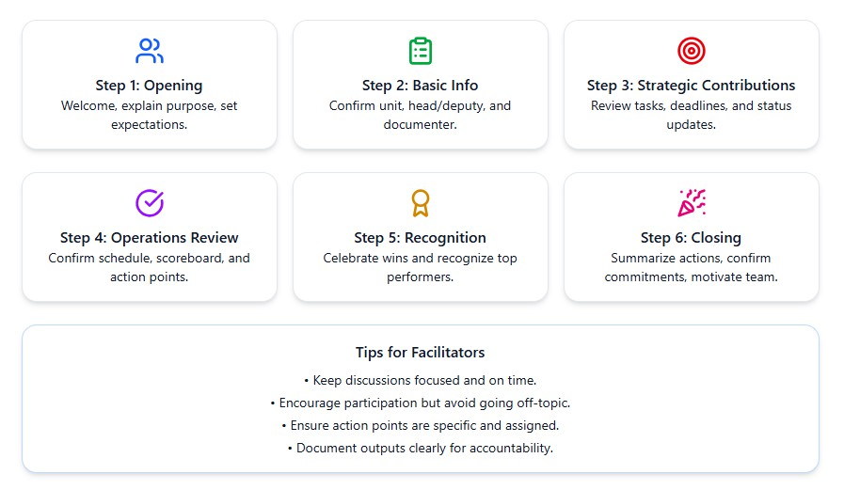
FACILITATOR’S GUIDE FOR OPERATIONS REVIEW

This guide is designed to help facilitators conduct an efficient and meaningful Operations Review. It provides a step-by-step flow to ensure that all essential topics are covered and that the session leads to actionable results.

Step 1: Opening and Orientation

- Welcome participants and state the purpose of the Operations Review.
- Remind everyone that the session aims to assess progress, address challenges, and plan actionable steps.

Step 2: Basic Information

- Confirm Department/Division, Head/Deputy, and assigned Documenter.
- Ensure attendance of key staff and clarify roles during the session.

Step 3: Strategic Contributions

- Review contributions/tasks aligned with the strategic plan.
- Discuss deadlines, status updates, and challenges faced.
- Identify tasks that need follow-up or support.

Step 4: Operations Review

- Confirm meeting venue, schedule, scoreboard location, and OIC.
- Present operational updates (using scoreboards or reports).
- Discuss key issues, gaps, and challenges.
- Fill out the Action Points table, assigning responsibilities, target dates, and status.

Step 5: Recognition

- Discuss how wins and milestones will be celebrated.
- Identify ways to recognize best performers formally or informally.
- Agree on the frequency of recognition to maintain morale and motivation.

Step 6: Closing

- Summarize key decisions and action points.
- Remind responsible persons of their commitments.
- End with a motivational message that reinforces teamwork and accountability.

Tips for Facilitators

- Keep discussions focused and time-bound.
- Encourage open sharing but redirect if the conversation goes off-topic.
- Ensure action points are specific, measurable, and assigned to the right people.
- Document key outputs clearly for accountability.

